Lacy, Phil (from Linked In)
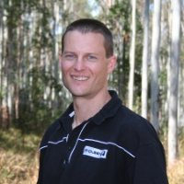

B.Sc. (Forestry) ANU 1989-1992. PhD, Fire Behaviour University of New South Wales 2005 – 2008 Thesis entitled 'Burning Under Young Eucalypts' .

Plantation Forester Forests NSW 1998 – 2003. Australian Fellow World Forest Institute 2003 – 2004. Farm Forester One Tree Agroforestry 2003 – . Project Officer, Fire Branch Forests NSW 2004 –2008 Coffs Harbour Area. Visiting Research Scientist CSIRO 2007 –2008 . Worked out of the Yarralumla Office with the Bushfire Research Group on my PhD thesis. Manager, Northern Operations PF Olsen (Aus) Pty Ltd 2009 –2012. Manager, Fire and Silviculture PF Olsen (Aus) Pty Ltd 2012 –2013 Coffs Harbour Area. Manager, Technical Services PF Olsen (Aus) Pty Ltd 2013 –, Ivanhoe, Melbourne.

Senior Instructor/Area Coordinator Outward Bound Australia 1993 –1995. Registered Professional Forester Institute of Foresters of Australia 1998 – . President Woolgoolga United Football Club
2010 –2012.

